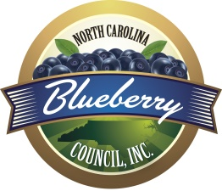
North Carolina Blueberry Council, Inc.

FARM / FACILITY MEMBERSHIP

January 2024 – December 2024
Memberships are on a calendar year basis. Renewals are due no
later than December 31 of the current year for the upcoming year.

Farm / Facility Name(s) __________________________________________________

Address_______________________________________________________________

City__________________________ State____ Zip_______ Phone_____________

Business E-Mail (important for updates) ___________________________________

List Up to 8 Members – PLEASE PRINT
First Name | Last Name | Email Address

Fee: $75 per farm/facility TOTAL ENCLOSED ________________

Check (made payable to NORTH CAROLINA BLUEBERRY COUNCIL

VISA MC AMEX CC #___________________________ Exp._______ Code _______

Signature (Name on Card) _________________________________________________

NOTE: In January 2021 NCBC members voted to continue assessing themselves on the sale of blueberries for another 6 years at the rate of 0.65 cents per pound fresh and 0.33 cents per pound frozen. The assessments serve as a means to promote research, education and general welfare of blueberries. Any person who produces less than 10,000 pounds of blueberries that are sold locally are exempt from assessments. Assessments are collected by the NC Department of Agriculture and paid to NCBC. Instructions for setting up your account for remitting assessments can be found on our website, www.ncblueberrycouncil.org.

Mail your completed form with payment to:
Brenda C. Park, Executive Director
NC Blueberry Council
213 Davidson Road
Greenville, SC 29609
864-361-1598 b.park@ncblueberrycouncil.org

